**(1) Find how many missing value :**

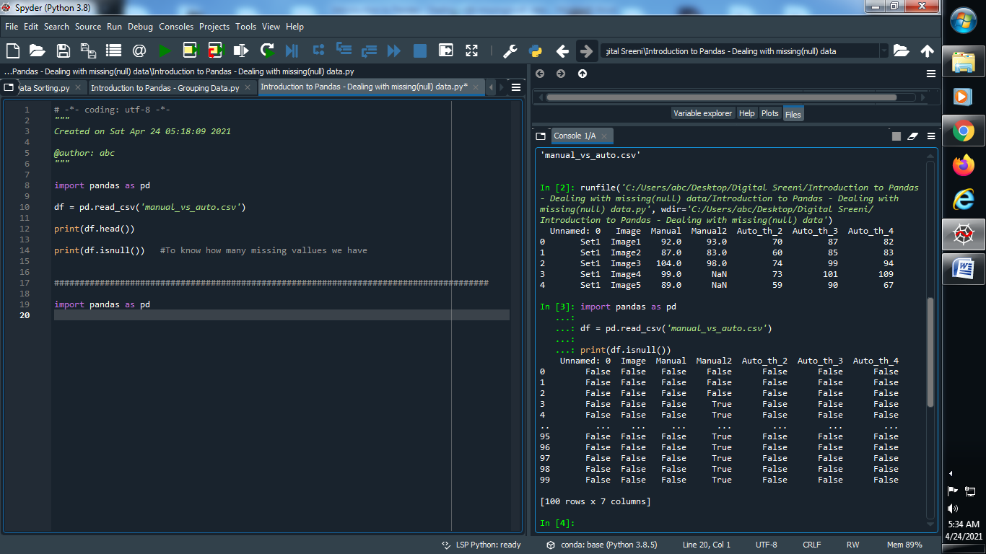

**Output :**



**Note : True is indicate it is missing**

**False is indicate it is not missing**

**(2) Delete Null values from the dataset**

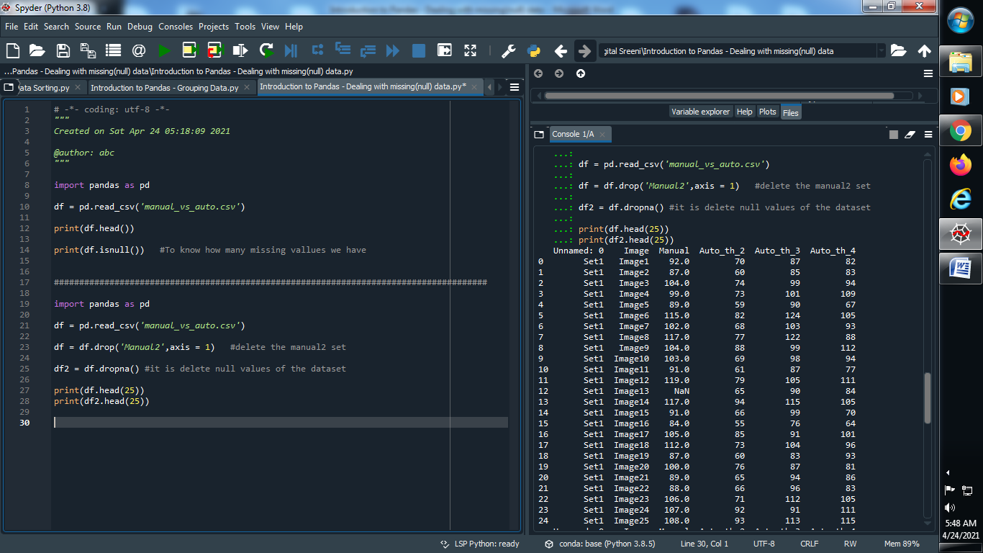

**Output :**



**→ It’s delete null values from the dataset**

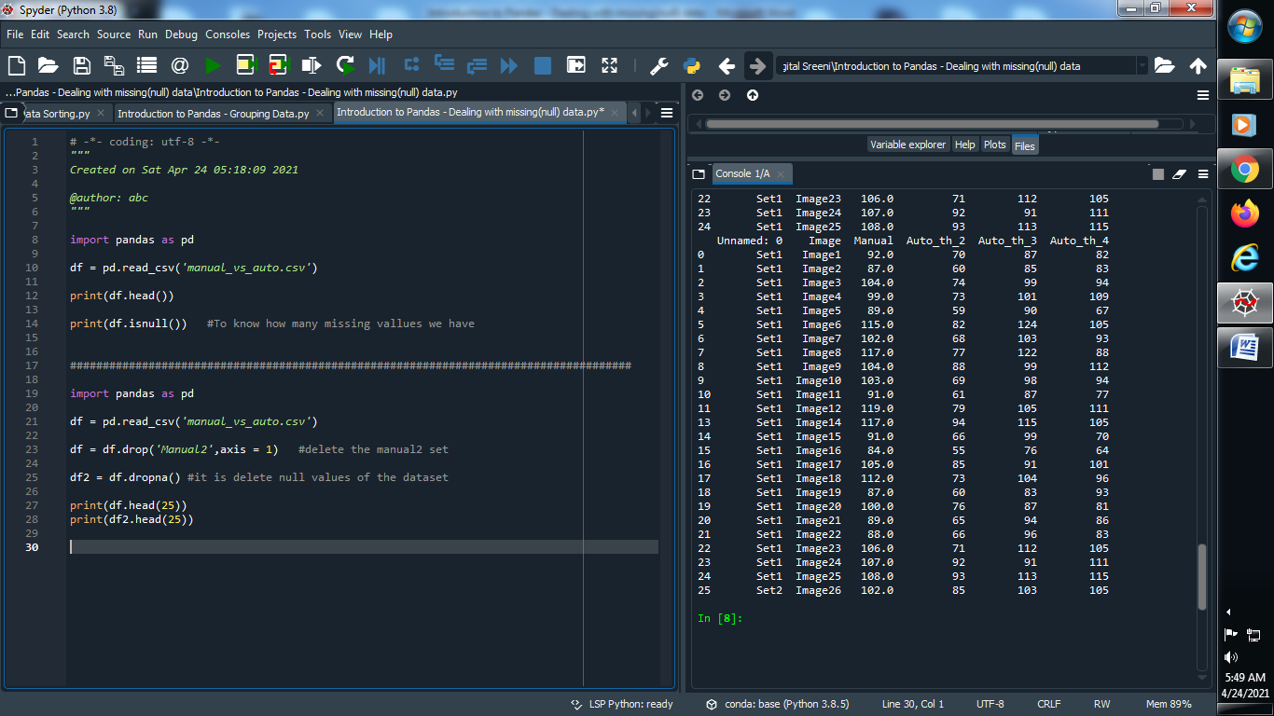

**(3) Print how many number of data is null**

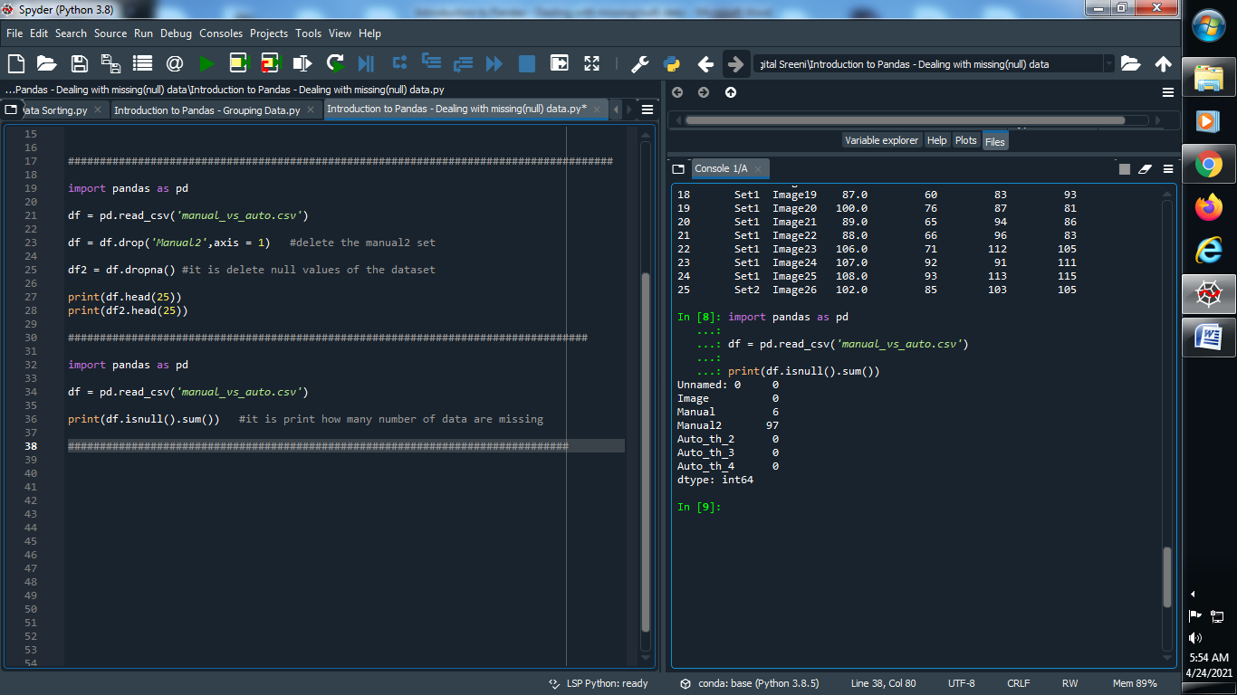

**Output :**



**(4) Fill the null values using imputation :**

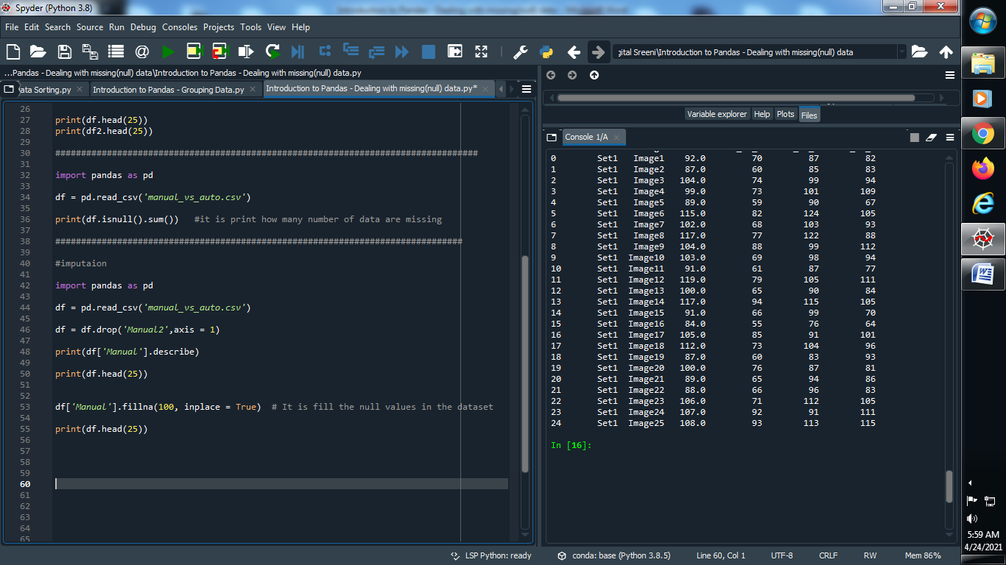

**Output :**

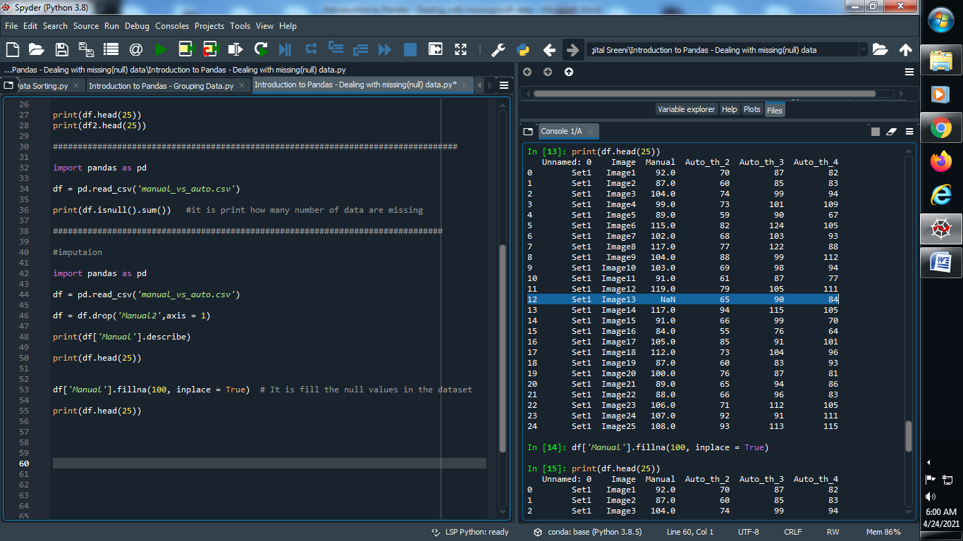

**Now fill this null value :**

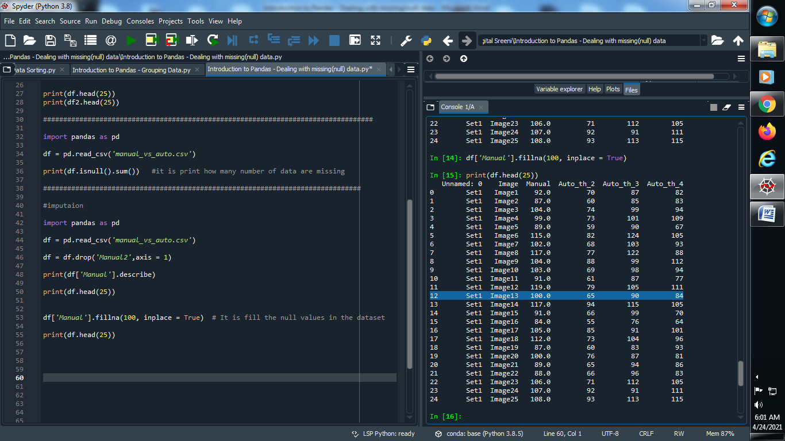

**(5) Fill the missing value using mean value of another rows :**

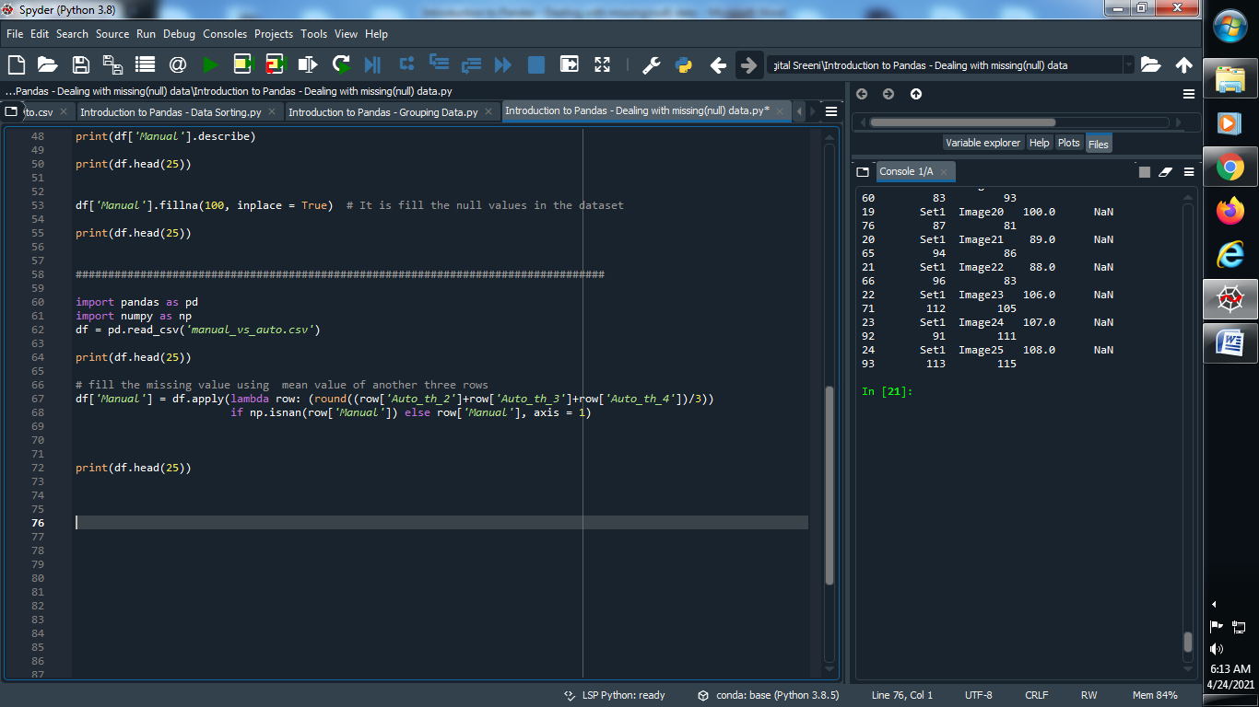

**Output :**

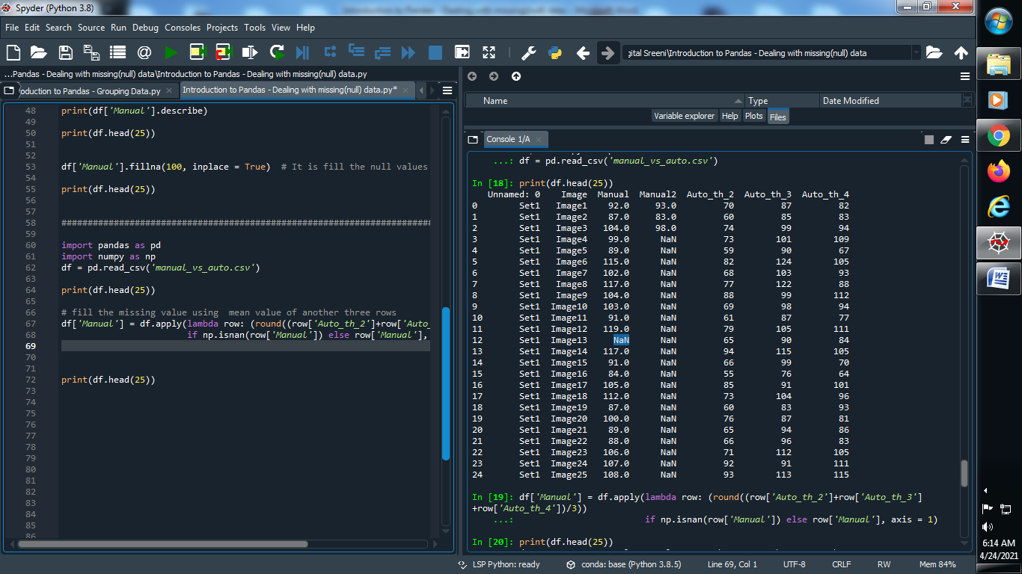

**Now fill the null value of manual column :**

